COPD RESCUE PACK INFORMATION

What is my COPD Rescue Pack?
Your COPD Rescue Pack contains a supply of standby medications to start if your COPD deteriorates before you can speak or see one of the practice team. Your COPD Rescue Pack contains two different medications:
• Steroid tablets: Prednisolone 5mg tablets to be taken with or after food
AND
• Antibiotic Amoxicillin 500mg capsules Note: Amoxicillin is a type of penicillin, if you are allergic to penicillin or amoxicillin, do not take this medication, instead inform your pharmacist and GP straight away.
OR
• Antibiotic Doxycycline 100mg capsules Note: If you are allergic to tetracycline, do not take this medication, instead inform your pharmacist and GP straight away
Please read this leaflet and keep it with your rescue pack medications.
When should I take my COPD Rescue Pack?
If you notice more than one of these symptoms:

- Increased shortness of breath – unable to carry out your normal activities.
- Increased cough
- Increased sputum (phlegm)

Start prednisolone tablets as you may have a non-infected worsening of your COPD. Do not use the Rescue Pack if it has passed its expiry date, instead contact your Doctor urgently to obtain a new supply. (Take six tablets immediately and then continue with six tablets as a single dose each morning, with food, for a total of 7 days)

AND

Increase your reliever inhaler (salbutamol or terbutaline) use.

If you notice one or more of these symptoms below, in addition to the previous symptoms
- Change in the colour, amount and/or consistency of your sputum (phlegm)
- Increased temperature feeling hot and shivery.

Start antibiotics (and prednisolone if not already started). Check the ‘use by’ date and if expired contact the surgery for a new supply.
- Amoxicillin 500mg capsules to be taken three times a day for 5 days.
OR
- Doxycycline 100mg capsules to be taken with a large glass of water twice a day for 5 days.

If there is no improvement in your symptoms within 2-3 days or your symptoms are getting worse contact the practice.
- Increased shortness of breath
- Chest Pain
- Drowsiness
- Confusion

In case of extreme emergency dial 999 for an ambulance.

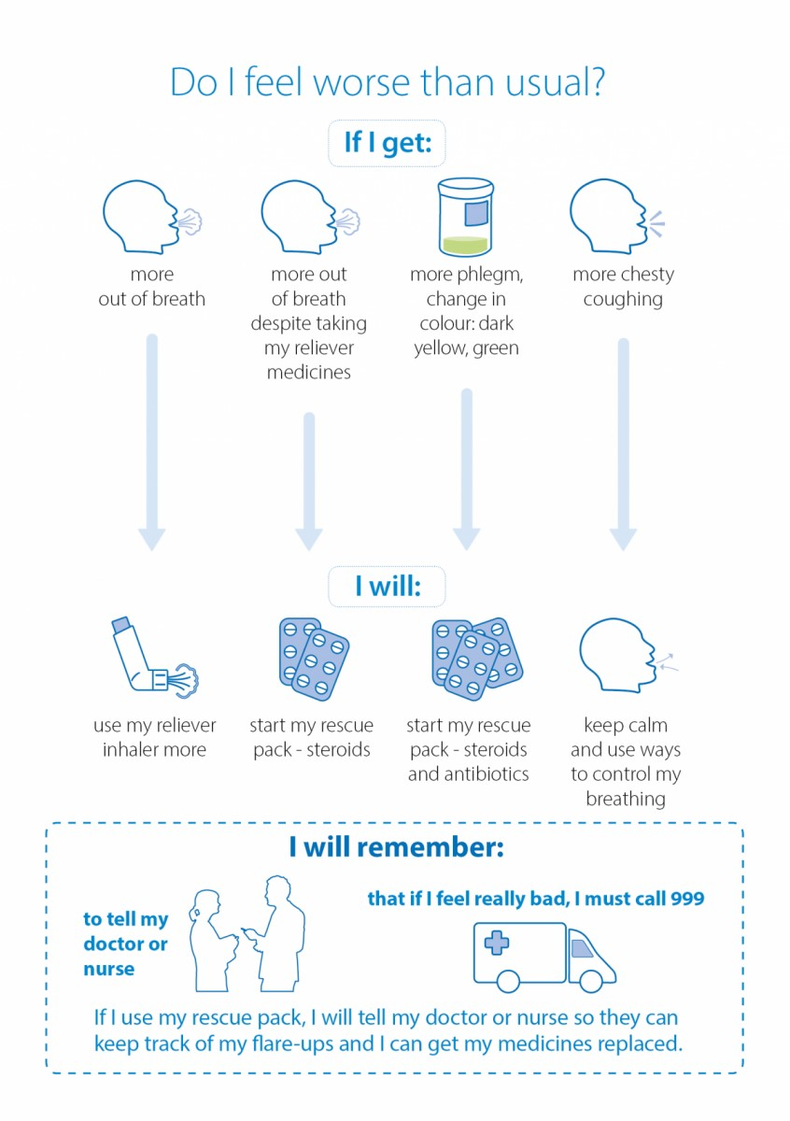

Once you have recovered.
Please let your GP surgery know if you have used your prednisolone and/or antibiotics and re-order another supply for you to keep in case they are needed in the future.

Important information
- Only start your rescue pack medication if you are having a flare-up of your COPD. You should have a COPD management detailing the steps you should take in the event of a flare-up of your COPD.
- If you do not have a current management plan, contact your GP or COPD nurse.
- Do not use the Rescue Pack if it has passed its expiry date, instead contact your Doctor urgently to obtain a new supply.
- What should I do if I’ve forgotten to take a dose? It is important that you take the medication as prescribed. However, if you forget to take a dose, take it as soon as you remember and then carry on taking your next dose at its regular time. If you realise you have missed a dose, but it is almost time for your next dose, do not take a double dose, skip the dose you have missed, take the next dose at its regular time, and then carry on as normal with any remaining doses.
- Are there any side effects? All medications may cause side effects. With short courses such as your COPD Rescue Pack, most people don’t have any problems. The patient information leaflets supplied with each medication within your Rescue pack list the more common side effects and other precautions. Please read these leaflets. If you are concerned about any side effects please contact your COPD nurse, GP, or Community Pharmacist for further information. If it is out of hours phone 111.

If you start your rescue pack but become more poorly, please do not ignore this. You must contact the practice and let them know that that you are less well even though you have started the rescue pack. If you develop any emergency symptoms, such as:
- severe breathlessness
- chest pain
- high fever
Contact the practice immediately or phone 111.
In an extreme emergency dial 999 and ask for an ambulance.

If you need to go to the hospital, please take all your medications with you.
Make sure you request a replacement rescue pack once you have recovered.

