What is a fever:
A fever is the body’s natural reaction to an illness. Fevers in a young child are common and the sign to look for is a temperature of 38 degrees centigrade and above; Most temperatures will reduce after a few days and the child is best cared for at home or in their usual surroundings.

Visual signs of a fever.
As well as a high temperature you might notice some or all the following:

- Mottled Rash
- Flushed cheeks.
- Hot to torso (tummy and back) but cool peripherally (hands and feet)
- Irritable and grumpy
- Sleepy/ lethargic

Causes of fever:
You may not be able to identify a cause for the fever initially but as the illness develops it may be easier to identify the cause i.e., Cold symptoms/ Chicken Pox

How to measure a temperature:
- There are several different thermometers, many are digital.
- Tympanic Thermometer- this is digital machine placed with the ear entrance.
- Axilla Thermometer- placed in the arm pit for a short period of time.
- Oral Thermometer- placed under the tongue for a short period of time.
- Forehead Strips- hold in place for approx. 15seconds.

If you do not have to have access to a digital thermometer to confirm a fever don’t worry as you can use your own judgement, you know your child better than anyone and therefore parental instincts is very important.

Treating fevers:
Medicines-
Paracetamol/ Calpol, this comes in 2 strengths- Infant and 6+
this can be given 4-6 hourly max 4 times in 24 hours.
Ibuprofen/ Junifen/ Calprofen/ Nurofen are all the same medication just different brands shops own is just as effective and more economical.
This can be given 6-8 hourly 3 times a day. Avoid if suspected Chicken Pox
You can stagger/ alternate if required throughout the day to achieve best comfort for the infant/ child.

Alternate nonmedicinal methods-
Cool Liquids
Ice Poles/Ice Creams
Strip down to nappy/ light clothing but cover if shivering

When to contact the Doctors:
- They develop a rash that does not fade when pressed- see glass test below.
- Your baby is under 3 months old and has a fever over 38c.
- Has a seizure/ febrile convulsion.
- Fever ongoing for more than 5 days.
- You are becoming more concerned about your child, please trust your judgment.
- You believe the symptoms are worsening.

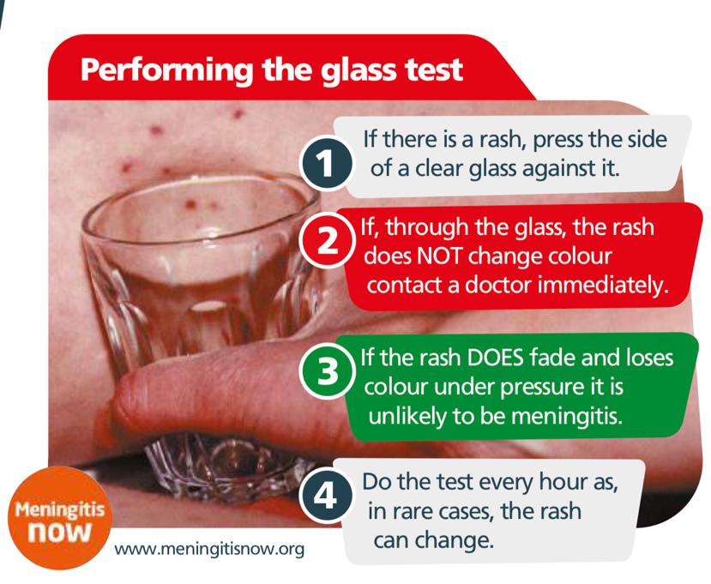

Links for further information:
Sepsis; Spotting the Signs https://wyhealthiertogether.nhs.uk/parentscarers/worried-your-child-unwell/sepsis-spotting-signs

Handi App Devon: https://onedevon.org.uk/our-work/services-and-support/children-and-young-people/handi-app/

Rachel Smith
ACP/ RSCN
Urgent Care Team
Beacon Medical Group
July 2023

